Smart Bank Business Processes

## Bank Manager Flow

1. **Login: Enter username and password.**

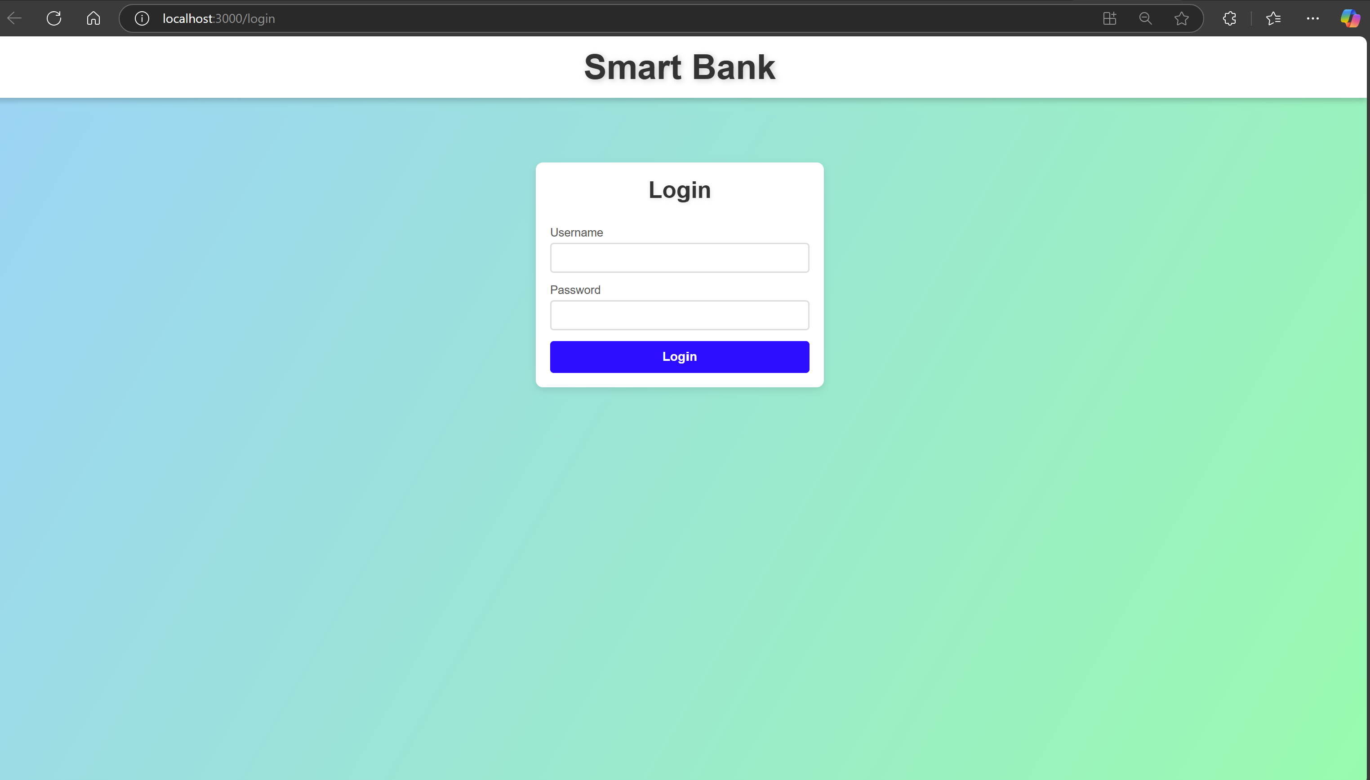

1. **Bank Manager Landing Page: Post login this page is displayed.**

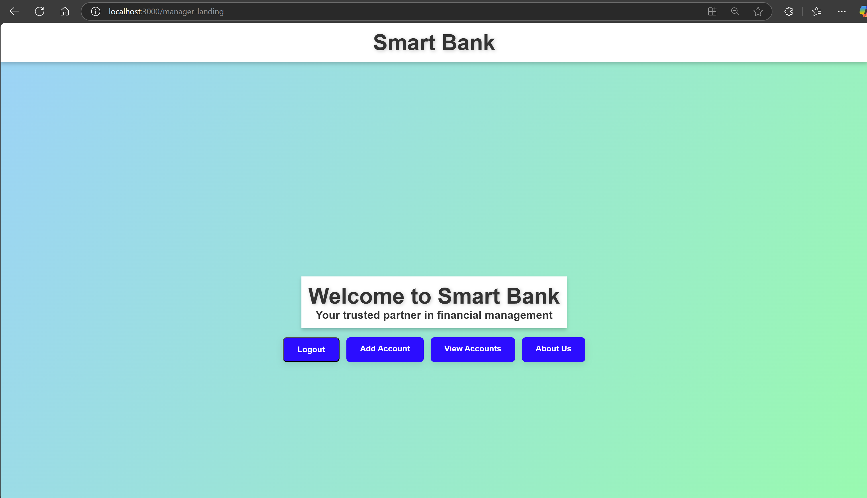

1. **Click on View Account**

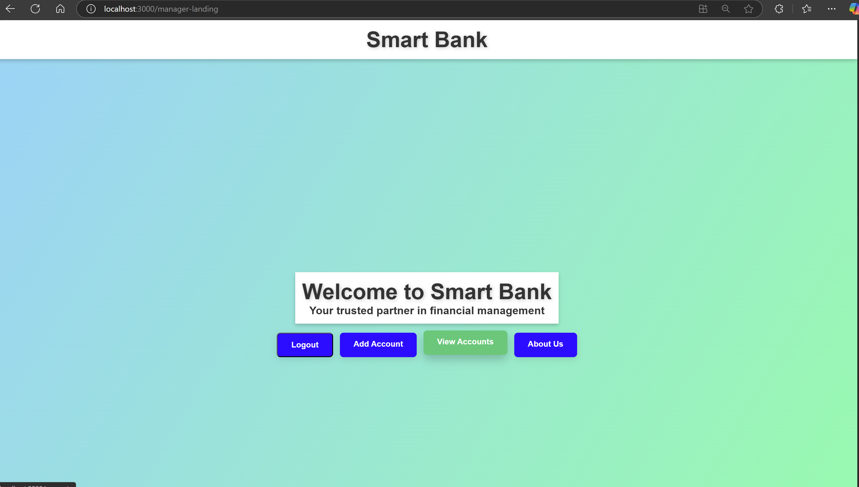

1. **All accounts in the bank will be displayed as cards.**

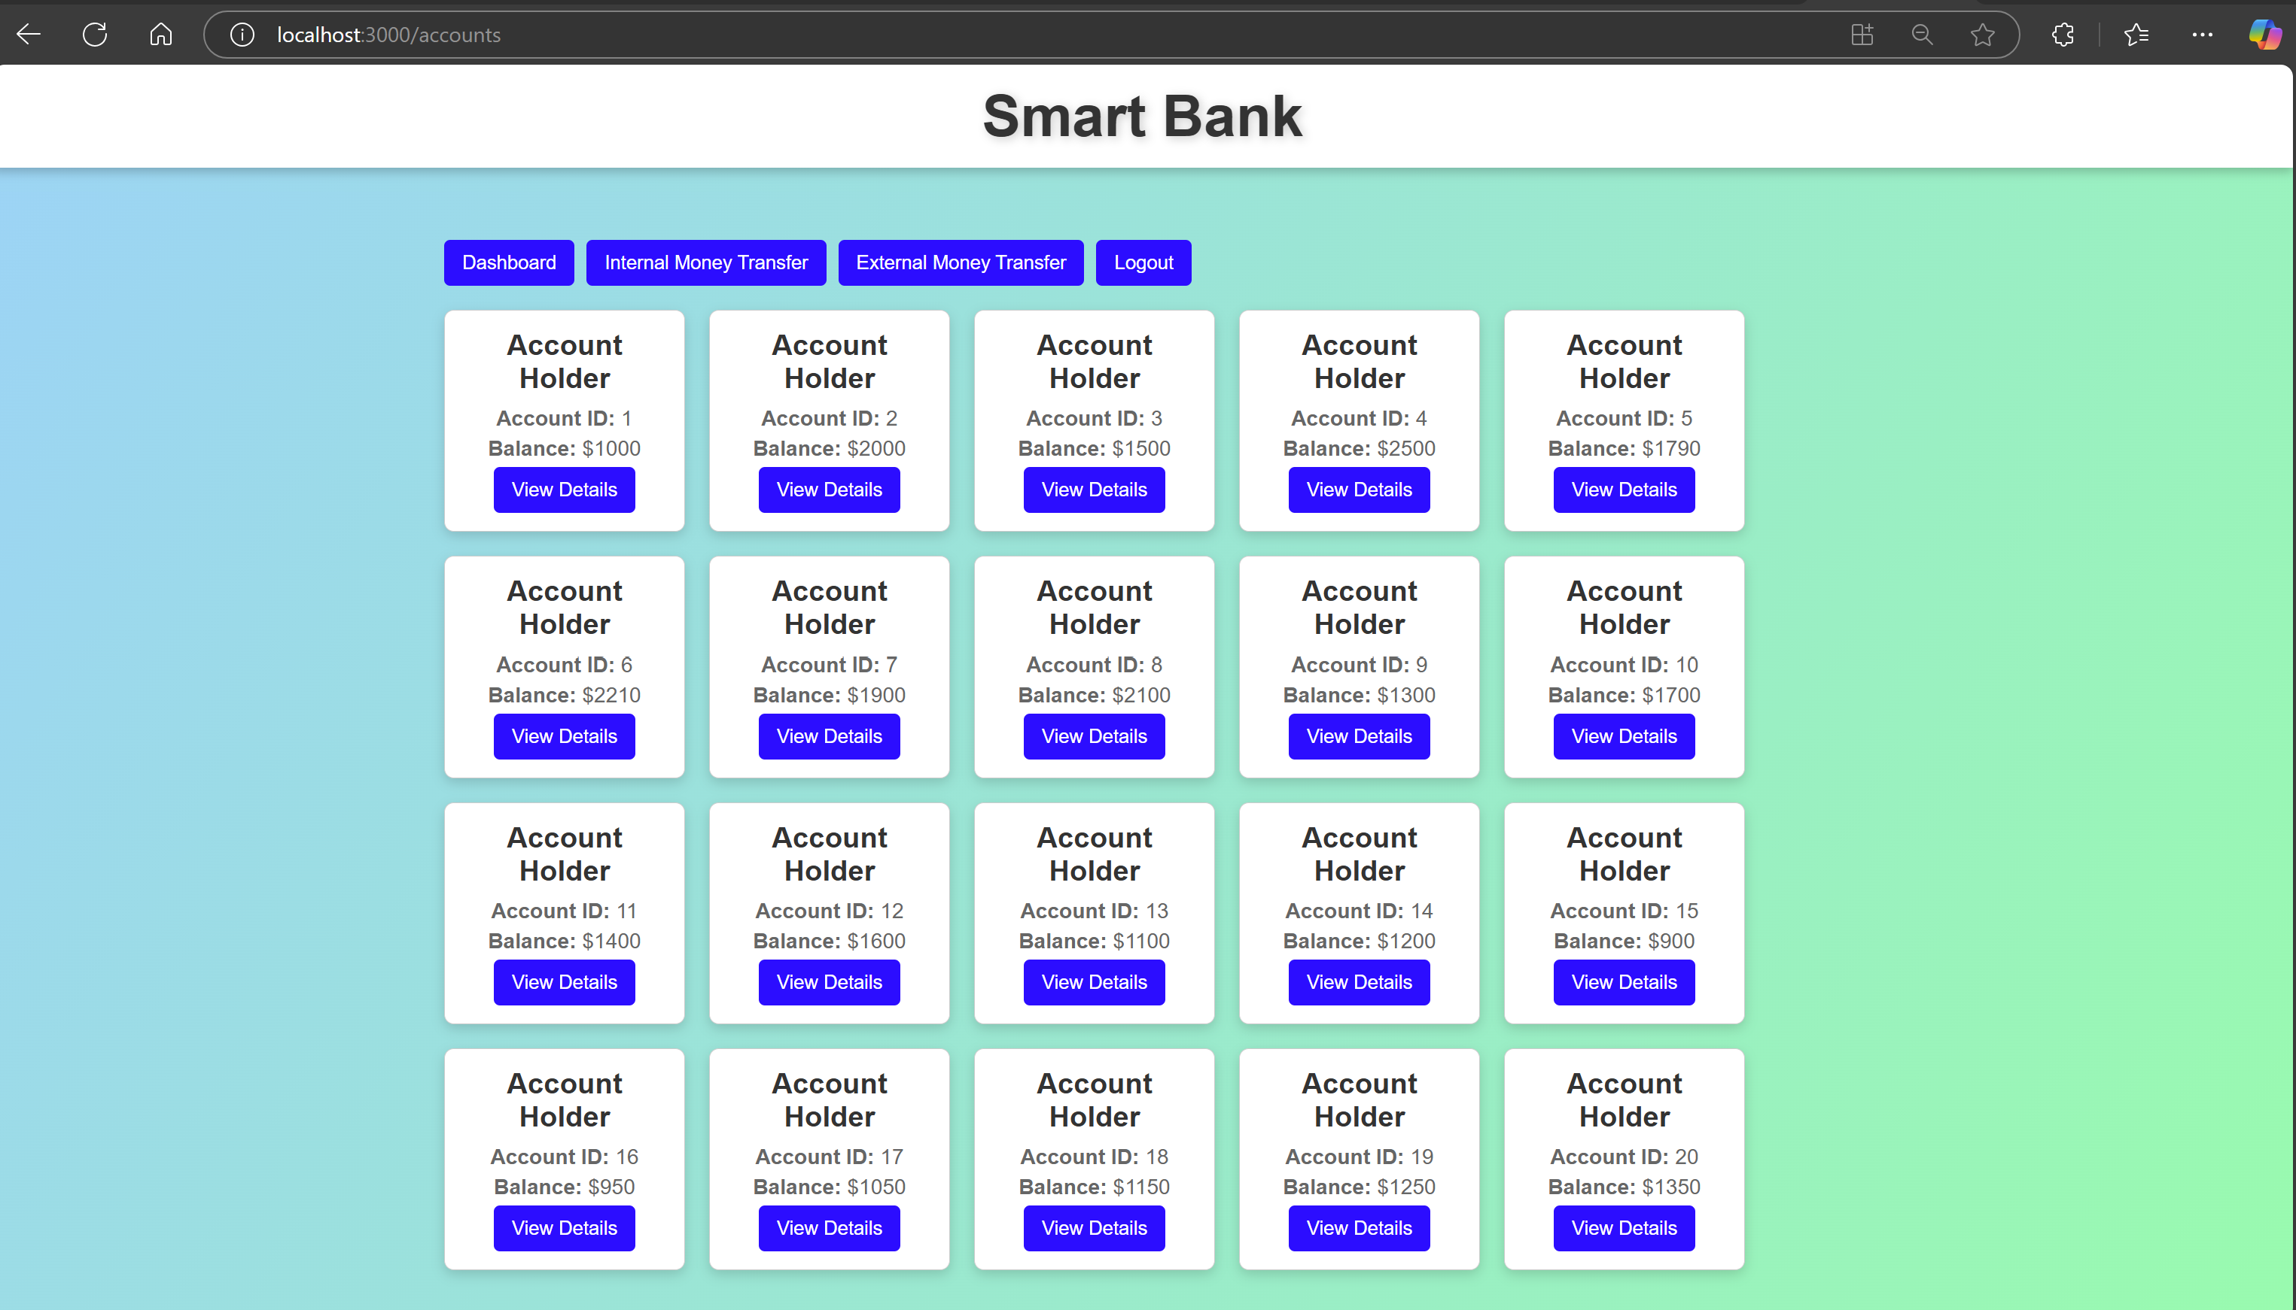

1. **Click on View Details of Account ID = 3**

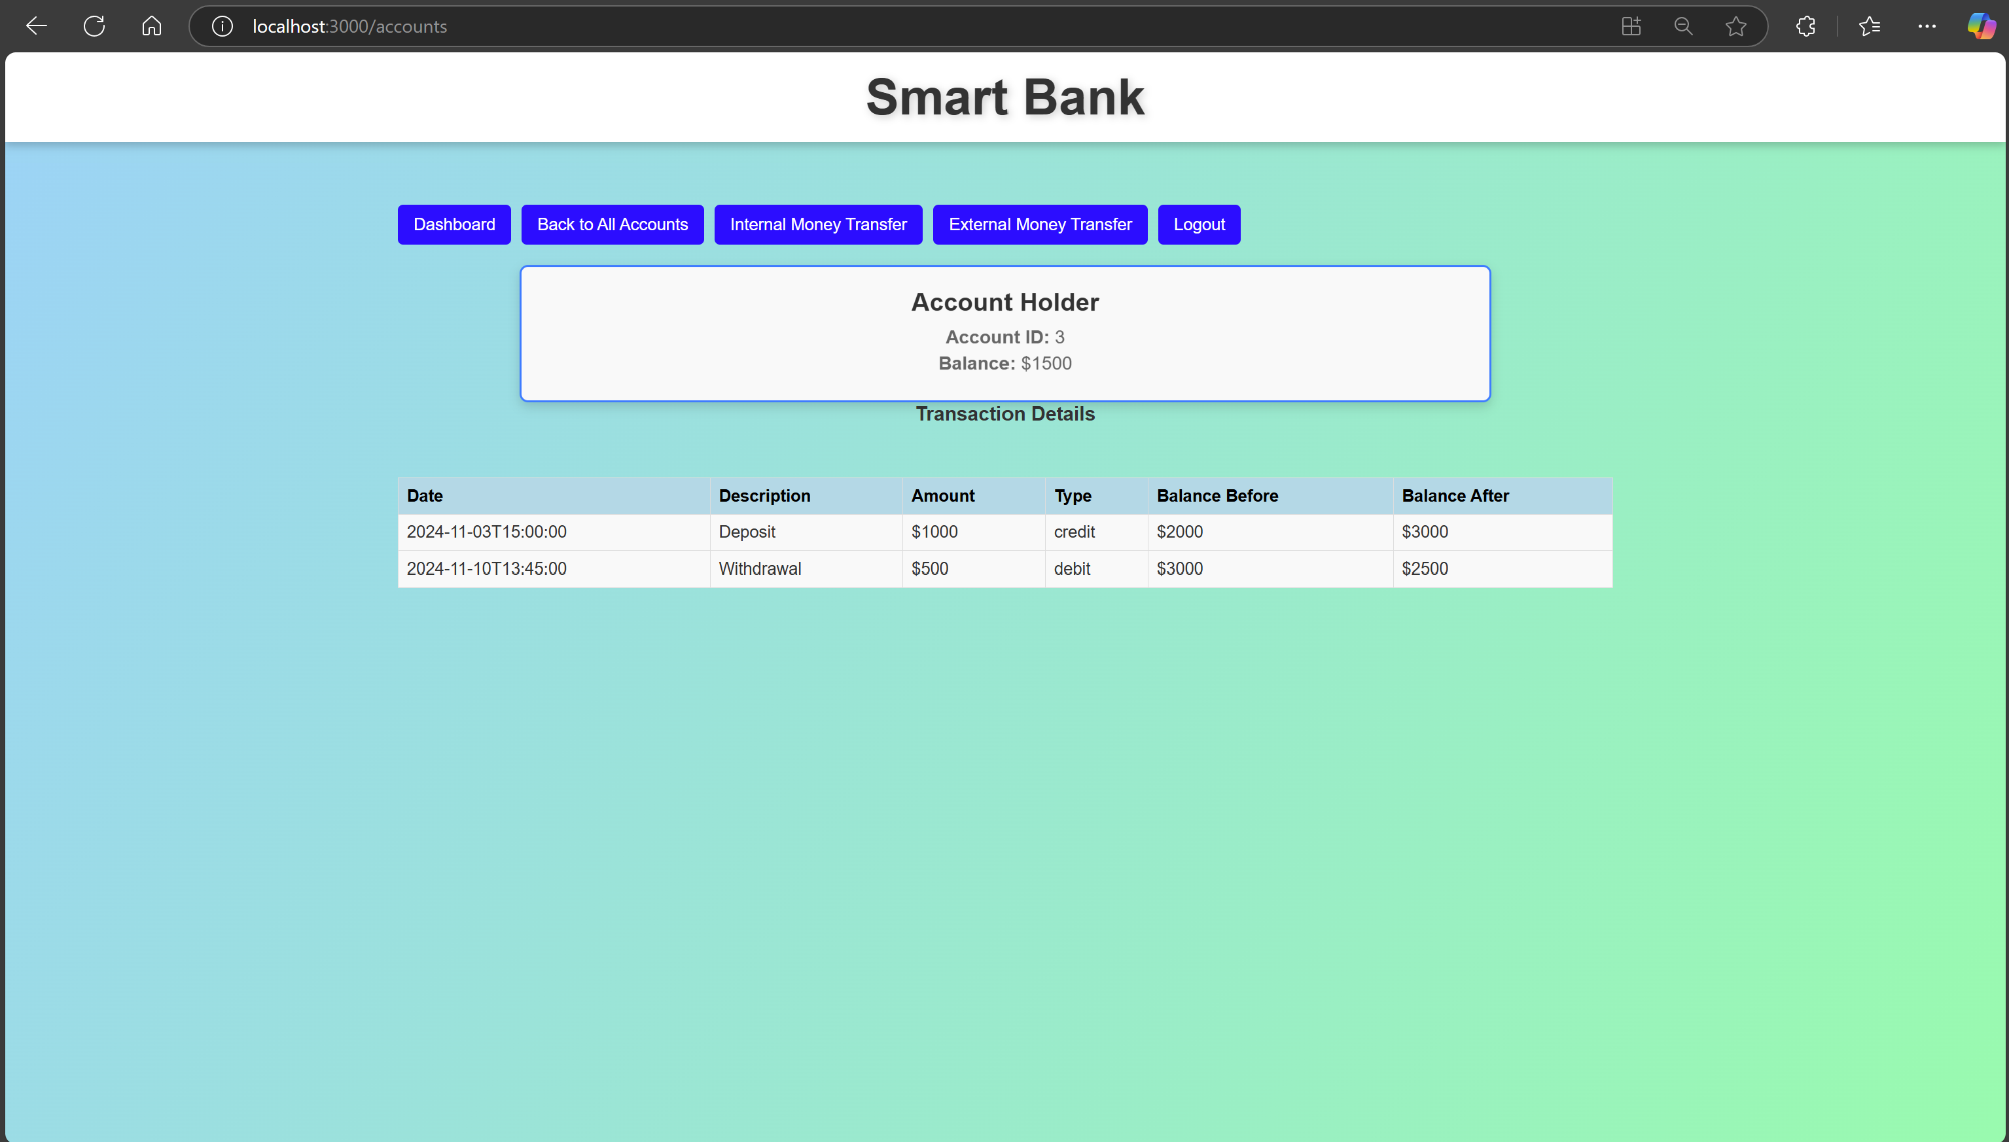

## User Flow

1. **All customers who are account holders have a role of ‘User’. Login Page remains same.**

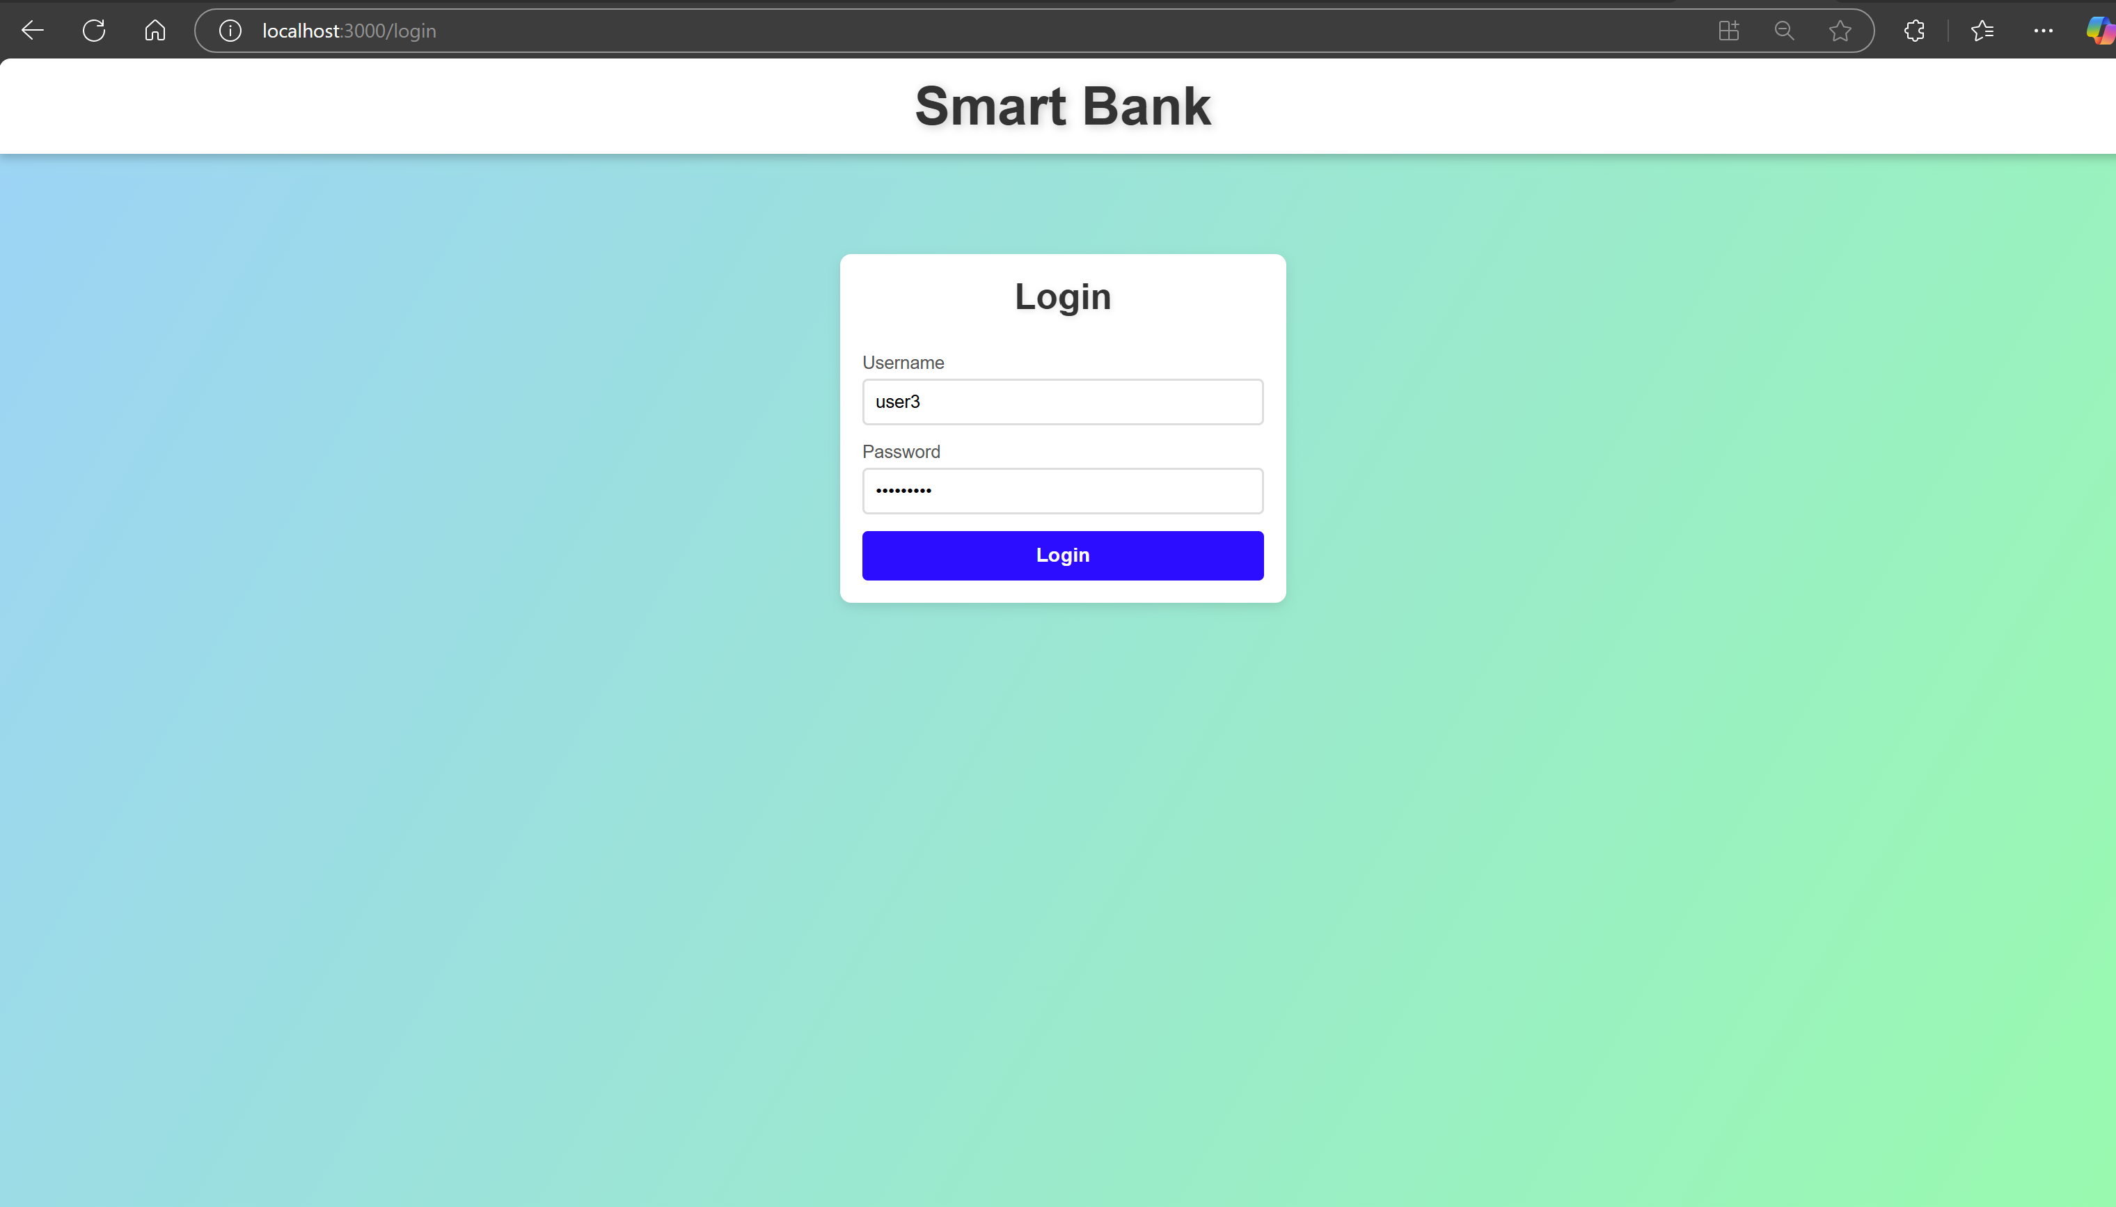

1. **User Landing Page: Post login this page is displayed.**

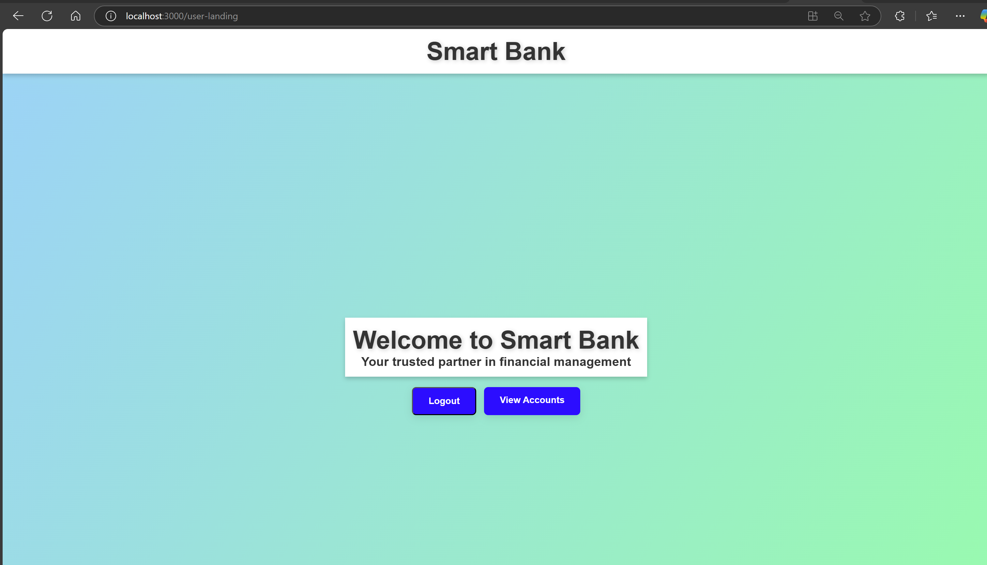

1. **Click on View Accounts to get details of Bank Account Id: 6**

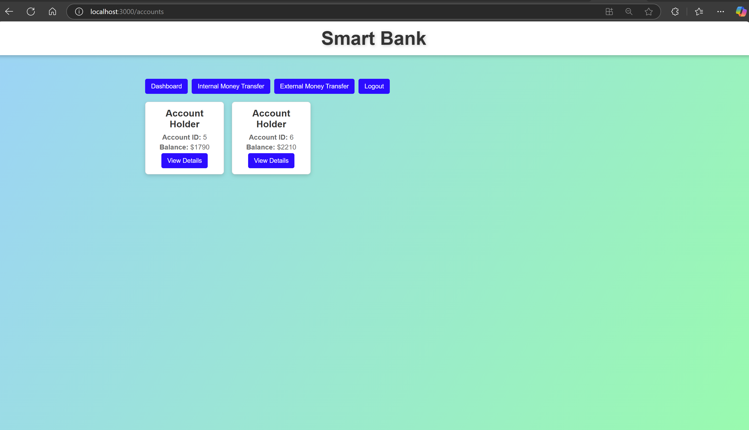

1. **Bank Account Details Page is displayed.**

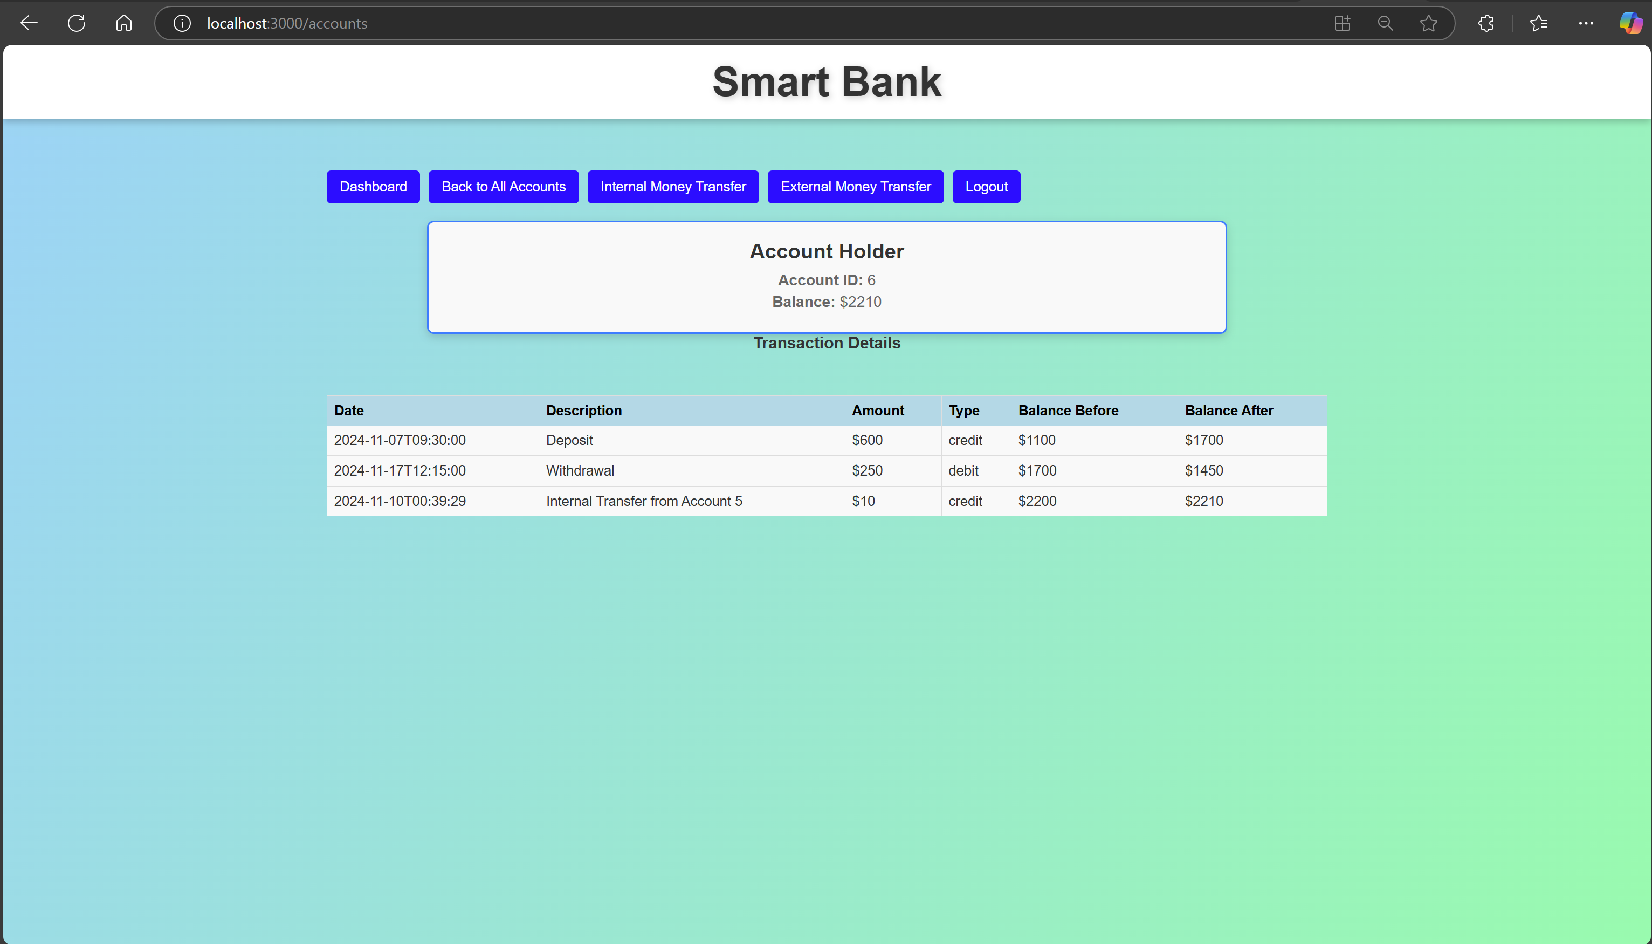

1. **Click on Internal Money Transfer Button to get the transfer page.**

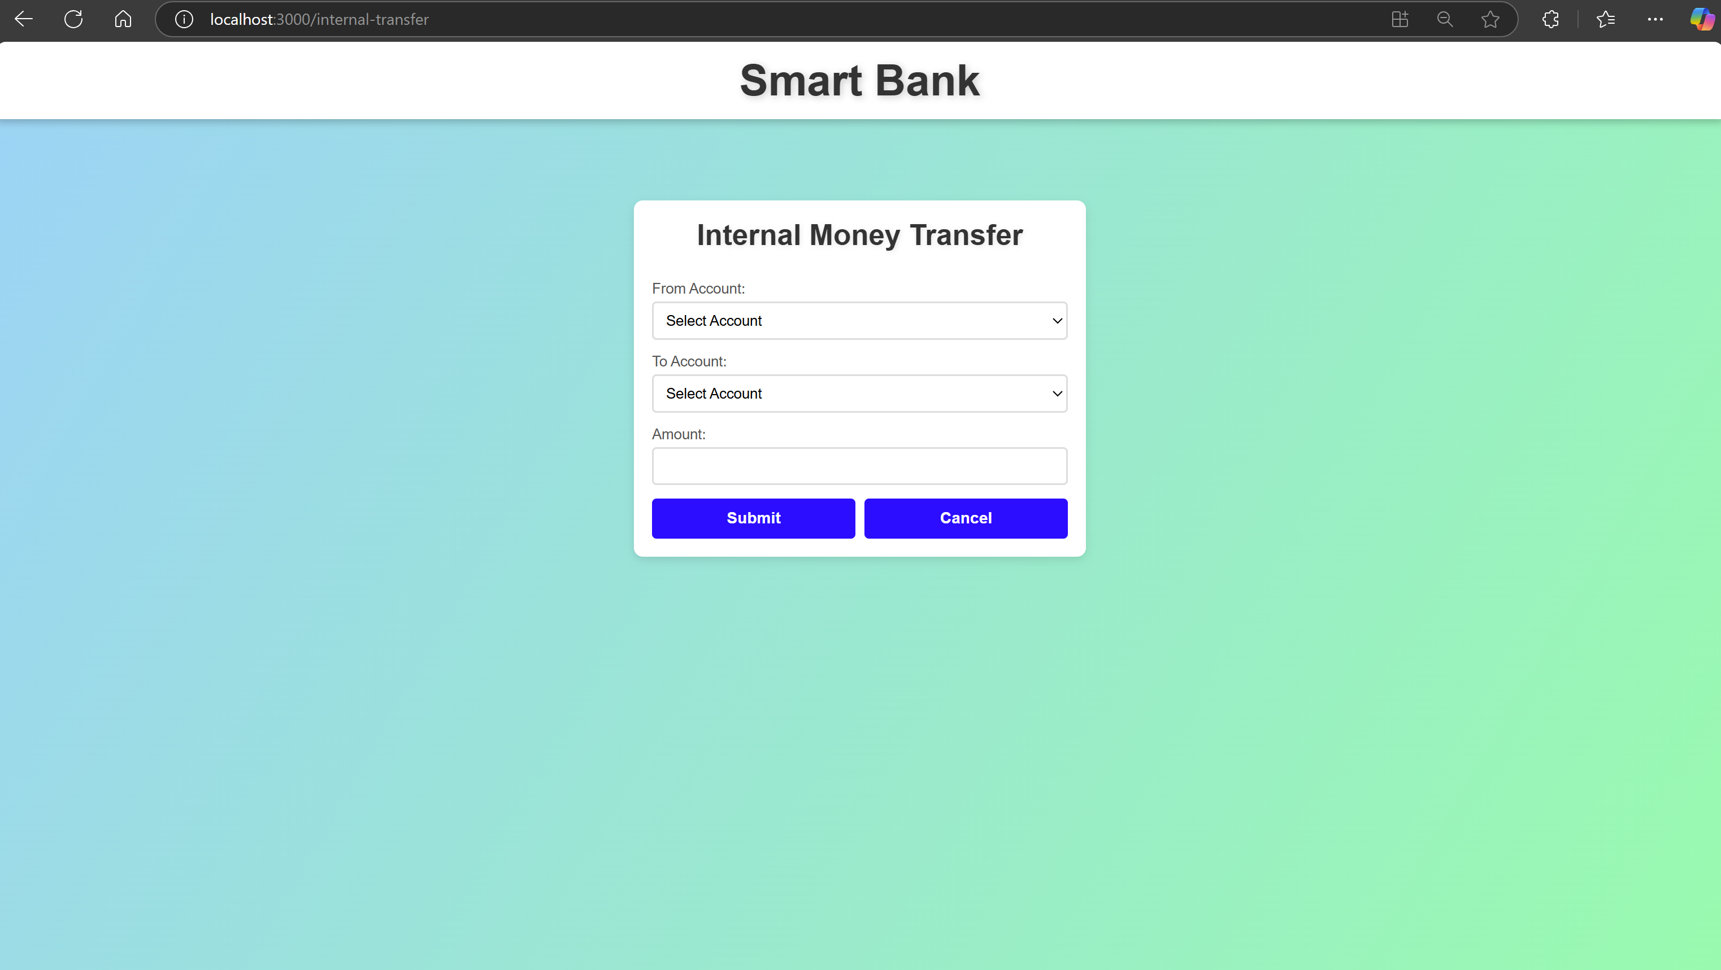

1. **Fill in details and click on Submit button to complete transfer.**

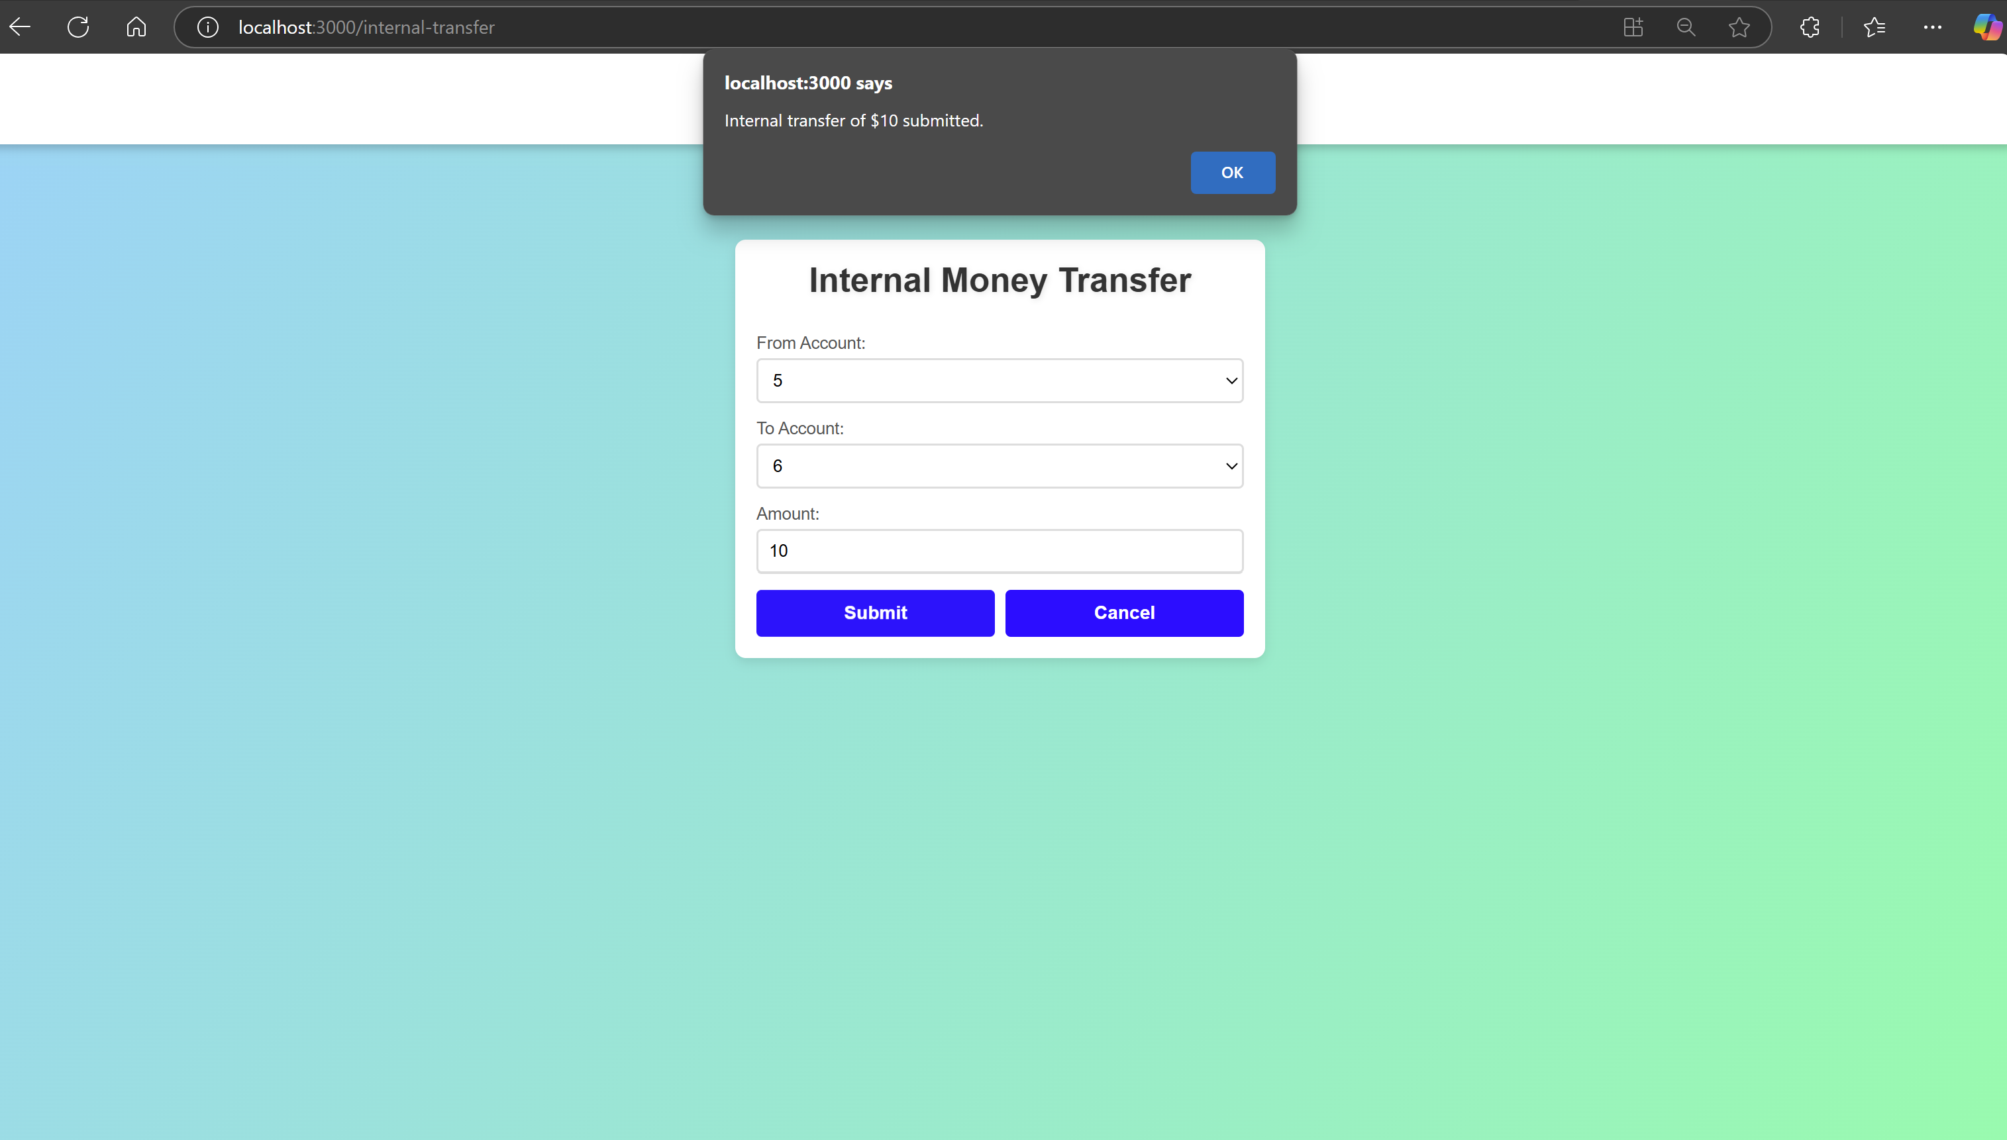

1. **Credited Money can be seen in Transaction List of Account Id 6**

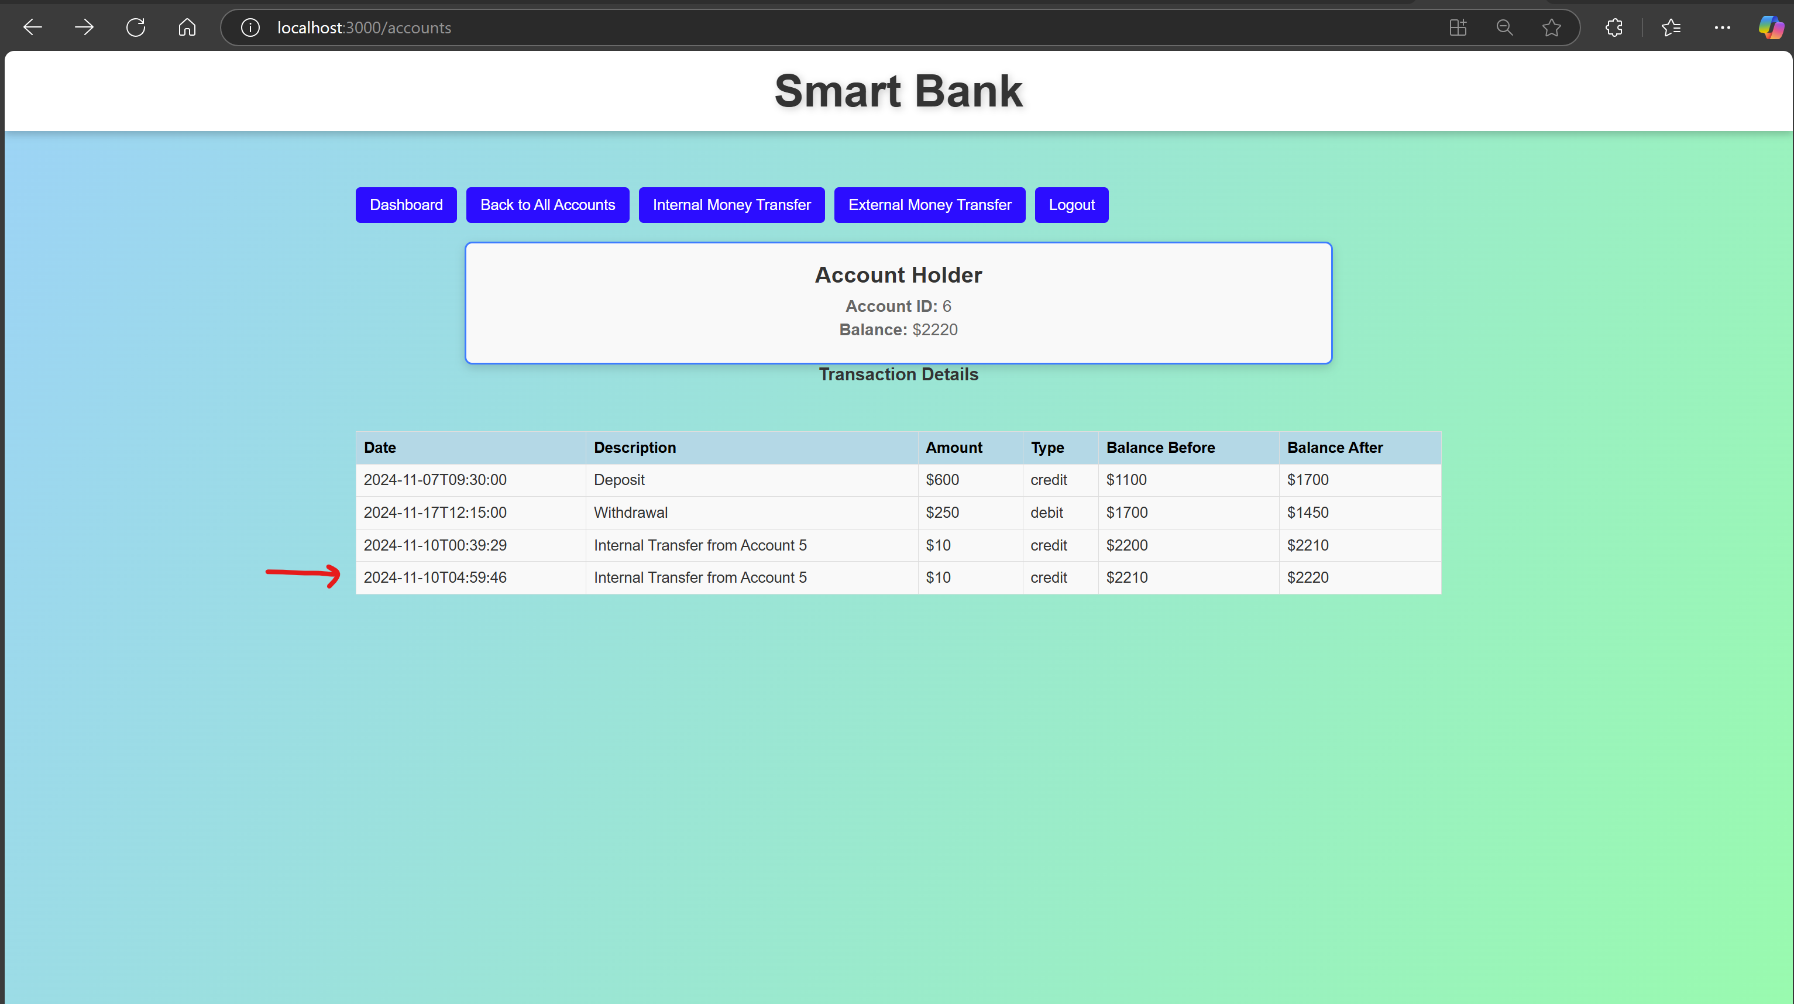

1. **Debit Money Transaction can be seen in Account ID 5**

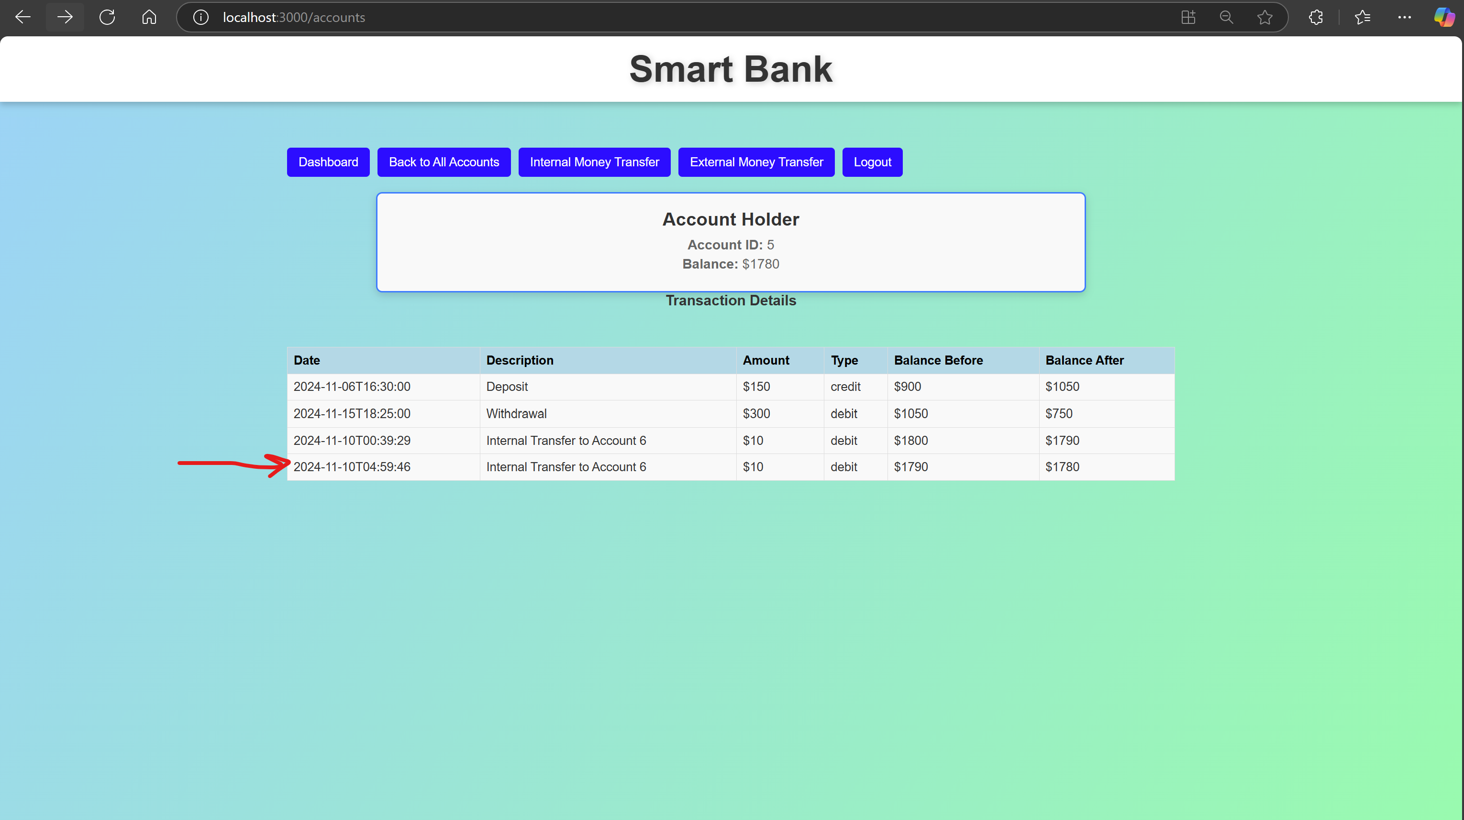

1. **External Money Transfer can be seen by clicking the External Money Transaction button.**

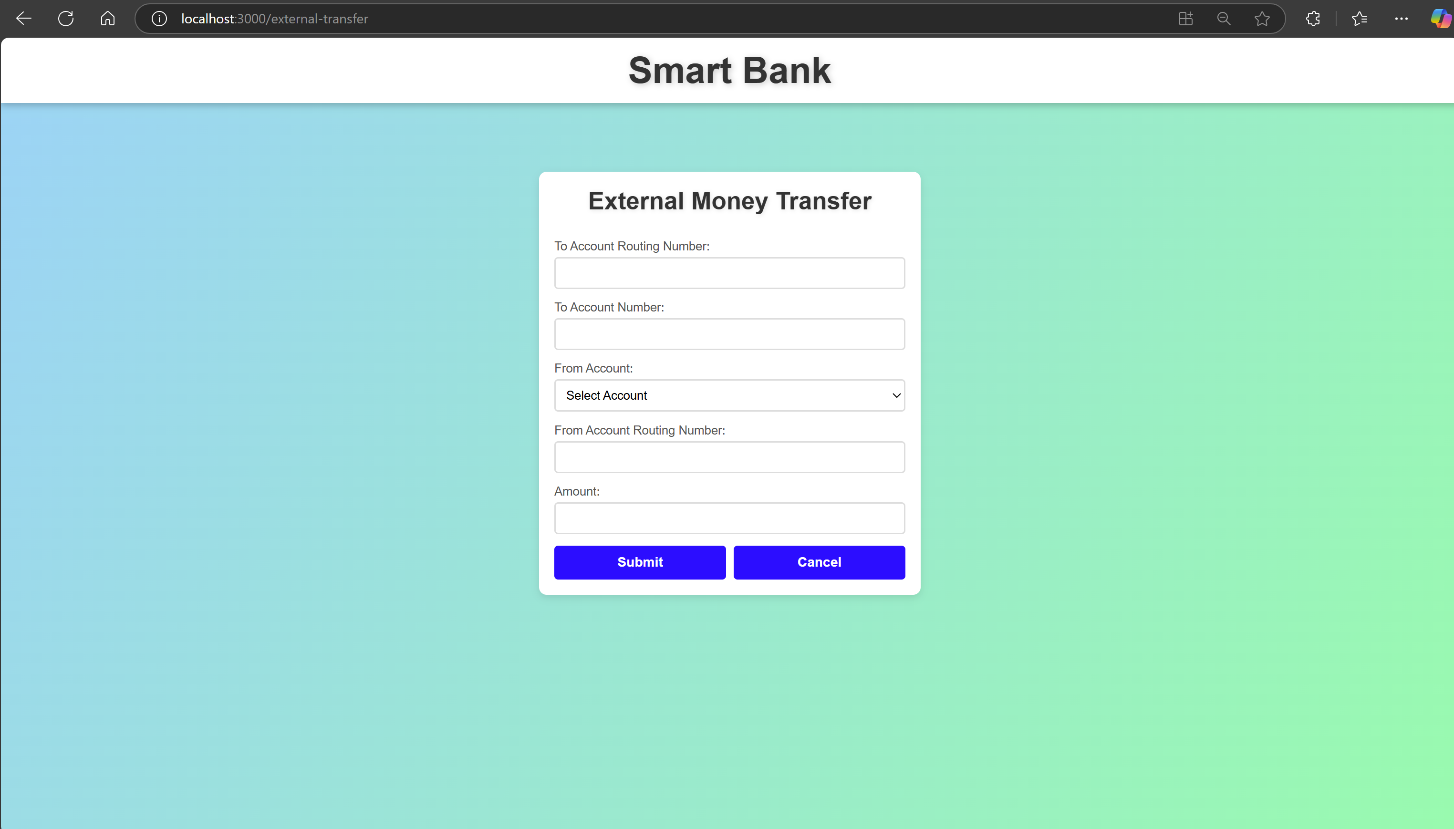

1. **Fill in details and click on Submit button to complete External Money Transaction**

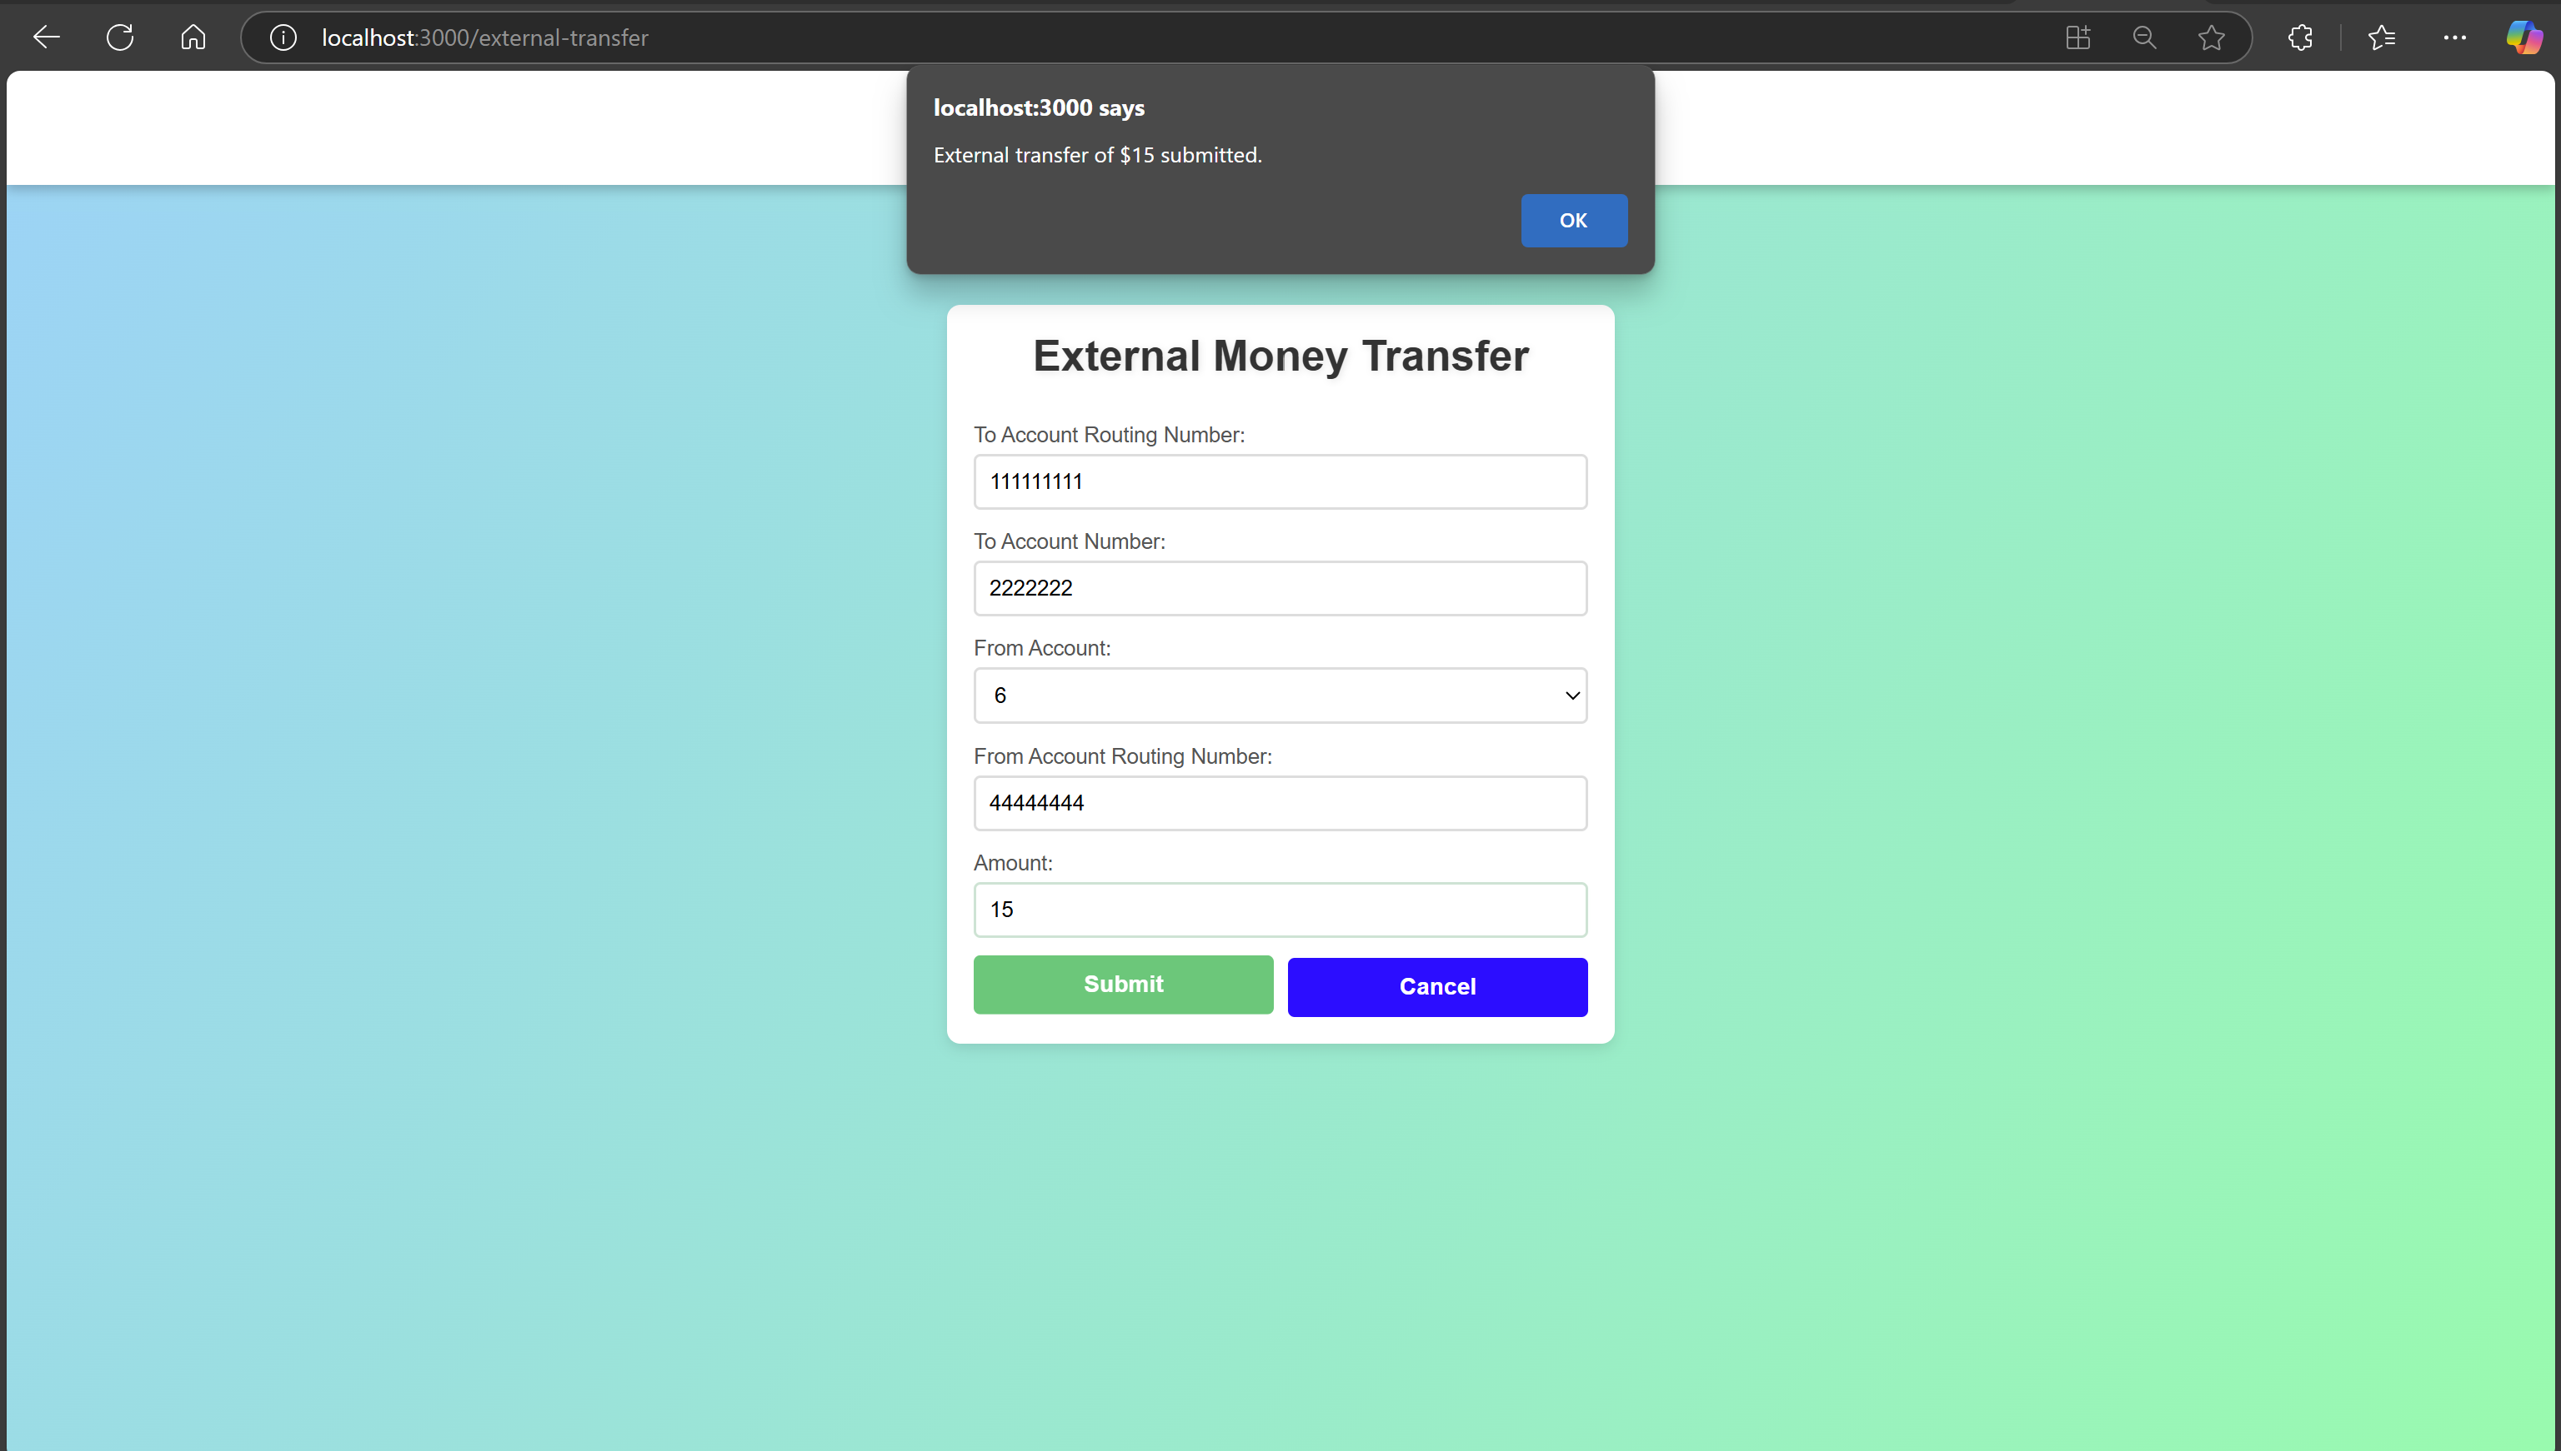

1. **Transfer Transaction can be seen in Transaction table**

